**How to install Metamask in 8 simple steps?**

Step 1: Go to <https://metamask.io/>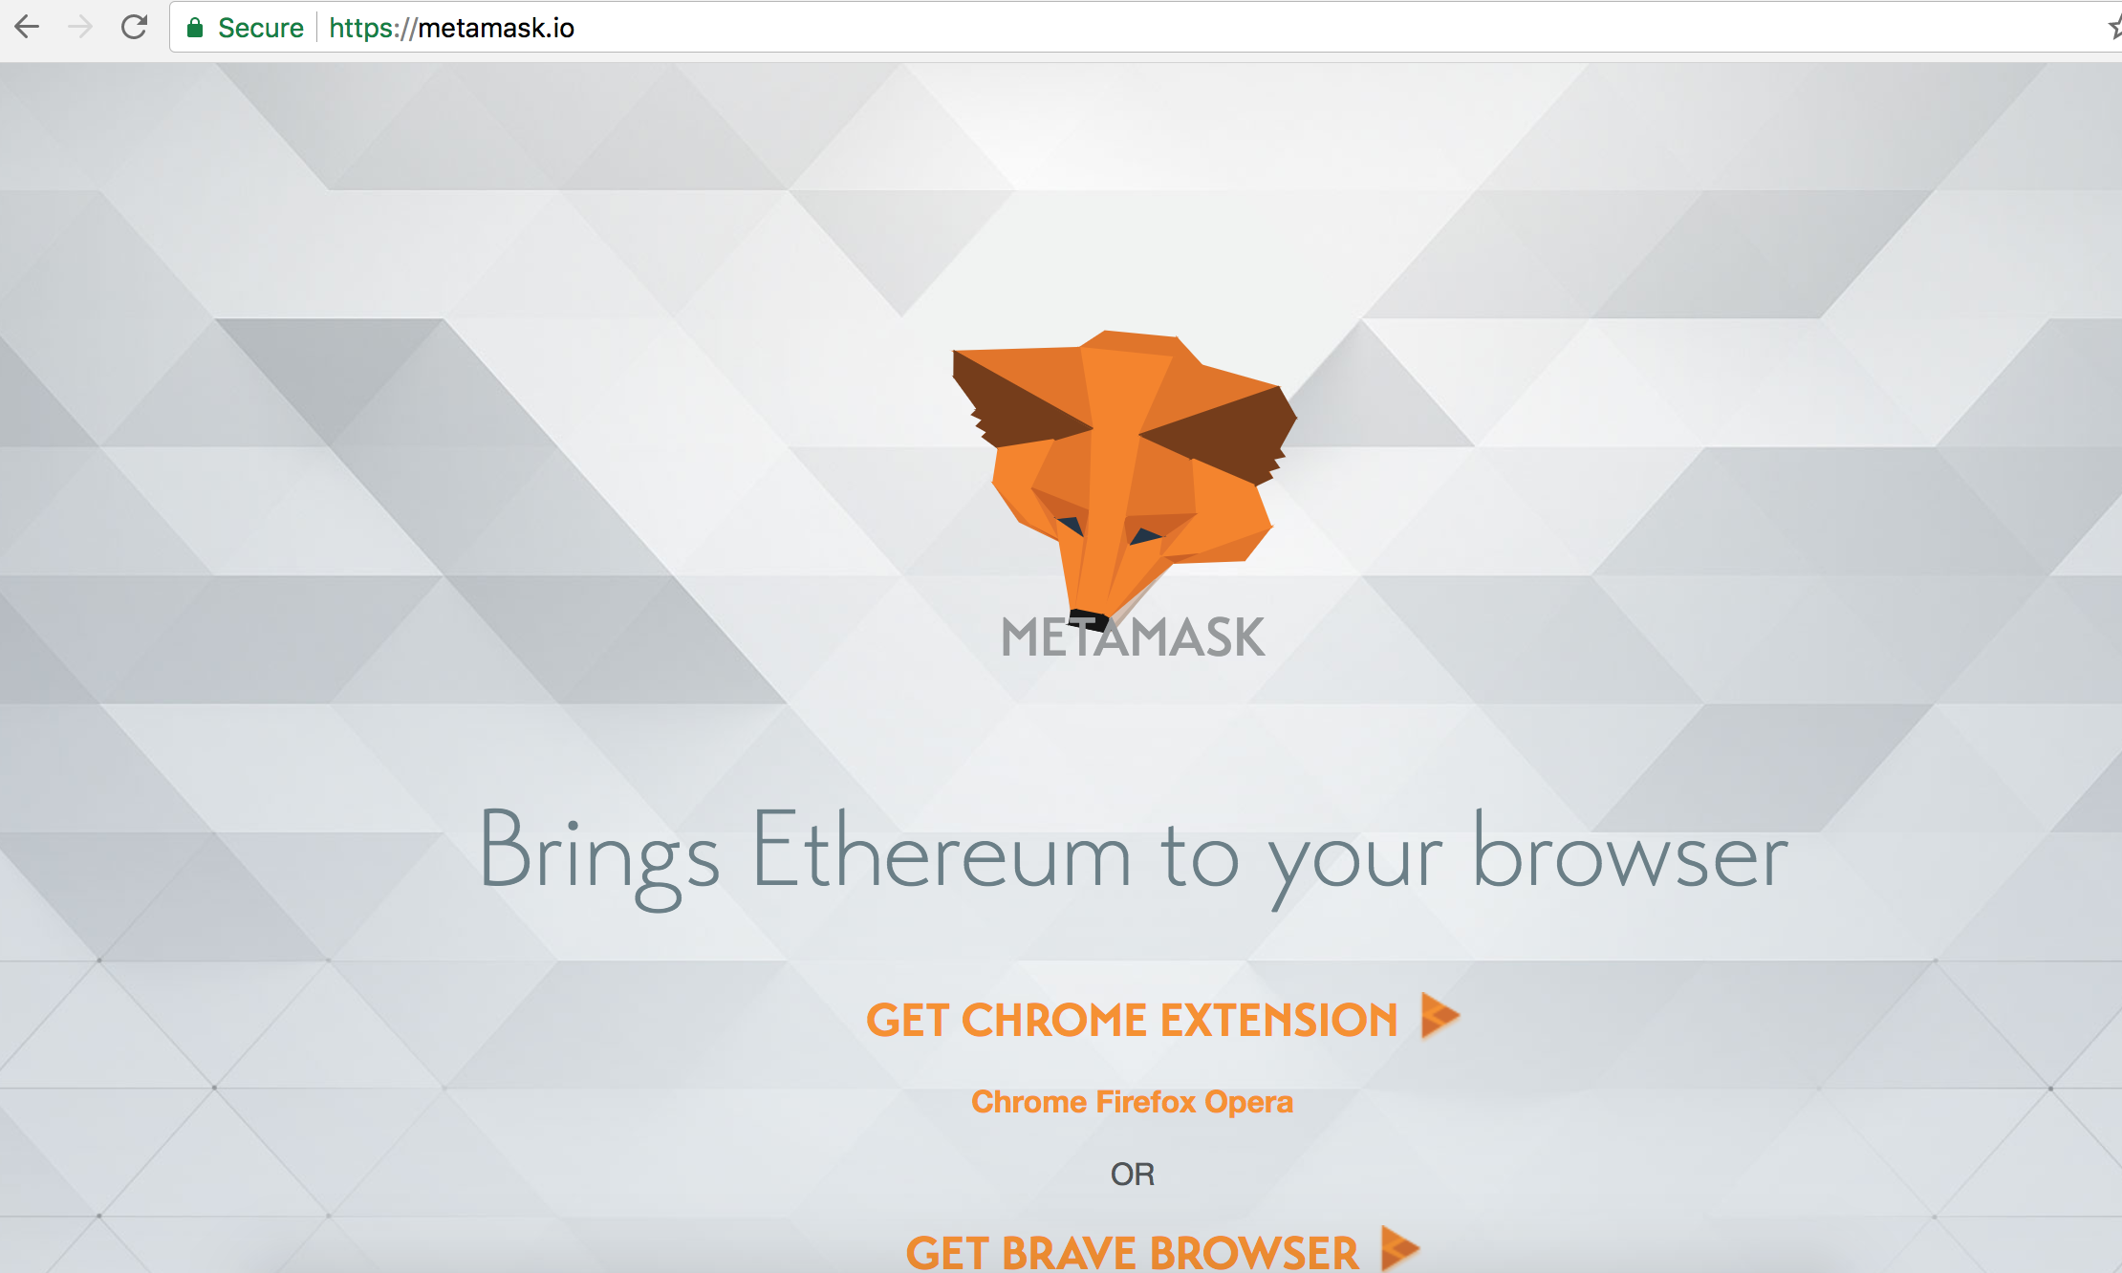

Step 2: Click on Get Chrome Extention

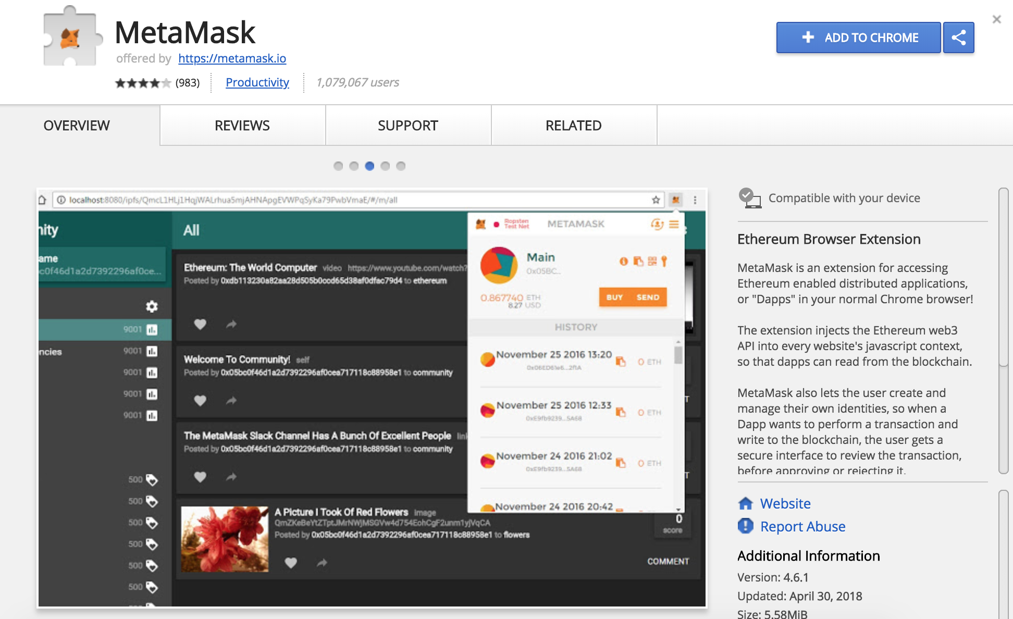

Step 3: Click ‘ADD TO CHROME’

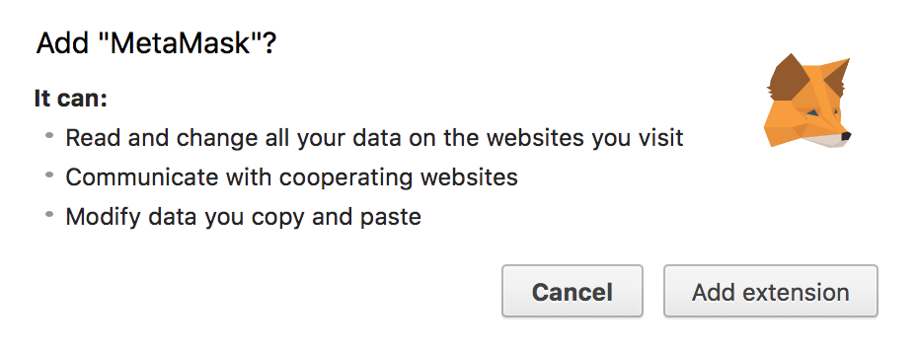

STEP 4: Click ‘Add extension’ . A small metamask icon apprears on right corner of your chrome browser. Click on it.

NOTE: Everytime you switch browser or change tabs, your metamask window will close. You will simply have to click on the metamask icon to bring the window up again.

Step 5: Click ‘Accept’

Step 6: Scroll down to terms of agreement and click ‘Accept’

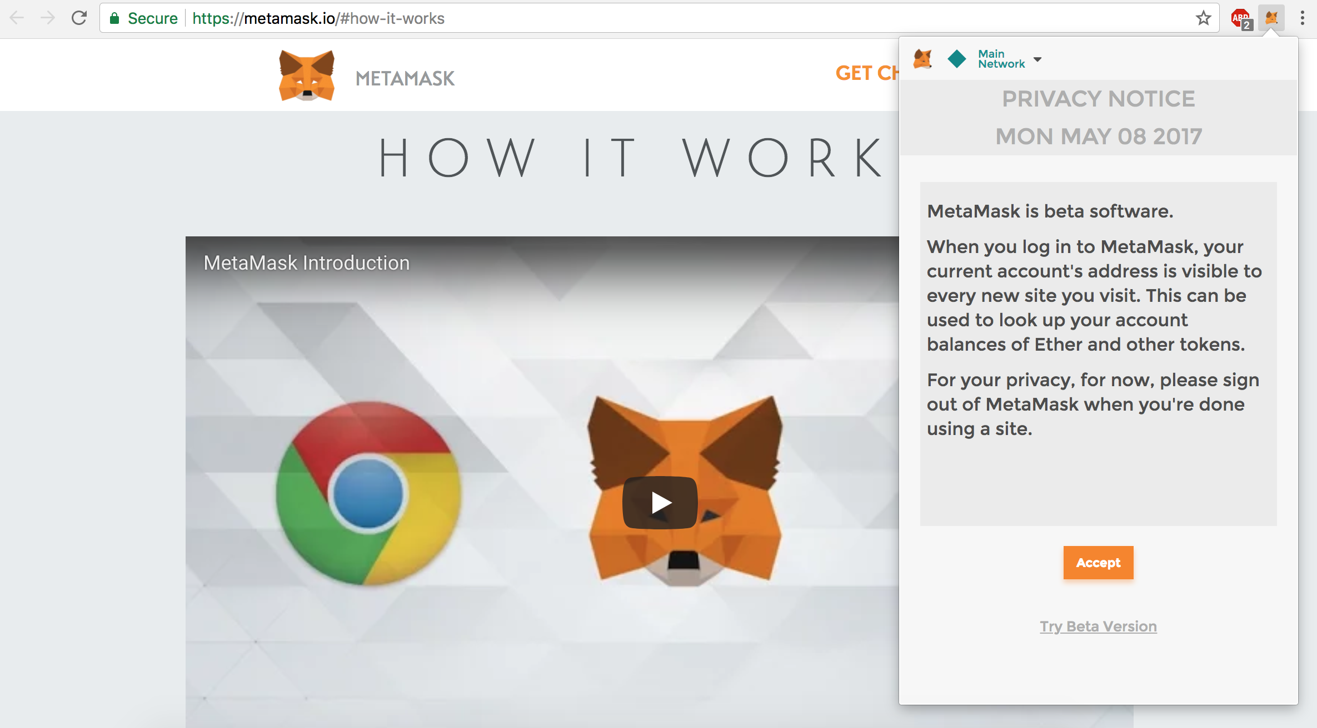

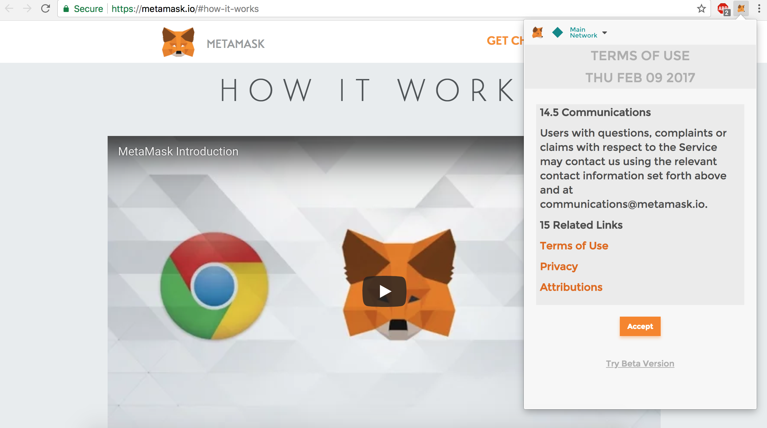

Step 7: Enter a password of minimum 8 character and click ‘CREATE’

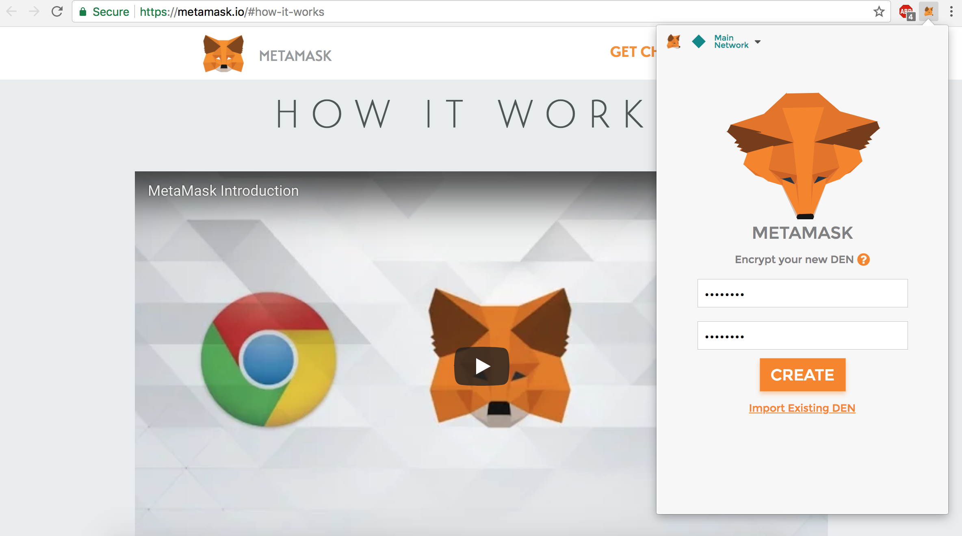

Step 8: Copy the seed phrase in the text box and save it somewhere safe and click ‘I’VE COPIED IT SOMEWHERE SAFE’

OR

Click ‘SAVE SEED WORDS AS FILE’ to save your seed phrase.

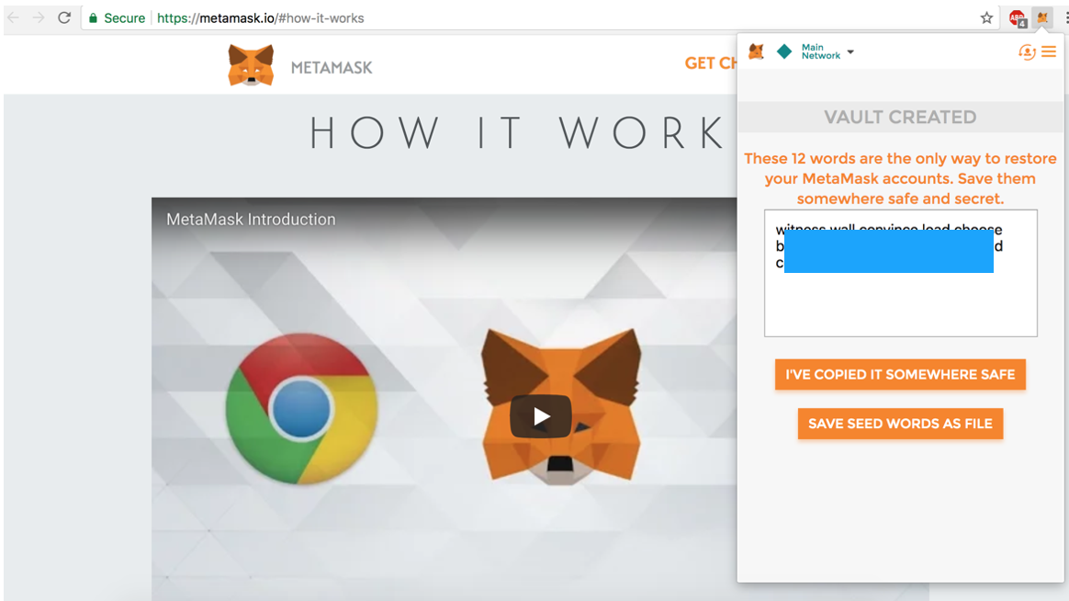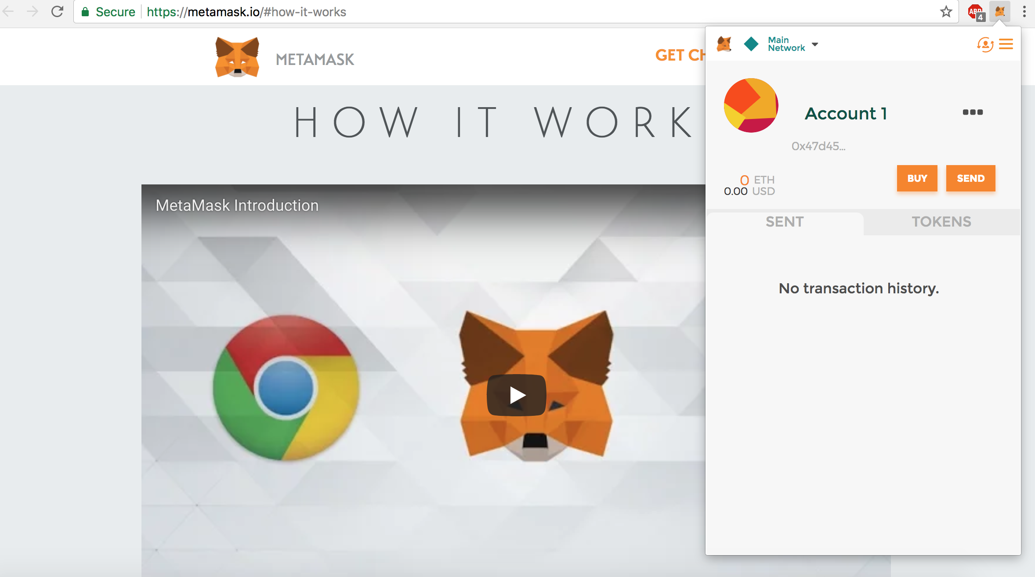

Voila! You have successfully installed metamask on your chrome browser.